Ako: ketang ali asagut okay mung jang ali mula asagut, pero palage ku asagut munalaman enaman kalupa ketang…

A: Ita mung sinabi mu nandin itang protocol.

Siya: Awa itang protocol. Ali itang protocol di, ali ke kasi masyadung apakibatan ita uling ngening new normal eku balu makananu na ing pamag handle case although me assign kung 4 years keng investigation, balu ku naman ing process ing filing of cases especially keng abuse. Nanu kailangan ba tagalog, English or…

A: Ali kahit nanu te.

Siya: Ah sige.

A: Aku na kasi mag kayi, I transcribe kemu din.

Siya: Ah sige sige awa.

A: Itang mumunang kutang kasi te, diba atin kayi te itang reglementary, kunwari ing victim megreport ya in 24 hours, makayi yaba kanta… 24 hours ba or 48 hours?

Siya: Dipendi keng case. If like for example, if ing case na is rape case, ing reglementary period na 36 hours. Pero dipendi parin, what if melyari ing rape case nakadwa (nung makalawa), nakadwa ya melyari ing case pwedi tayang I file ing case by Regular Filing. Adwa la kasing klasi deng filing, regular ampo pang inquest. Nanu la reng pagkakaiba da reng adwa, halimbawa megreport ya ing ating asawa, me abuse ya keng asawa na, nung nakadwa yapa megreport, ene pweding lungub keng inquest filing, regular filing nemu ing malyari, unlike ing inquest kapag melyari ya nandin pwedi tayang damputan ing tawu, pwedi tayang I arestu ing tawu. Inquest filing yayta, pwedi tayang I arestu ing tawu unlike ketang regular na melyari nakadwa pa. Kaya ing malyari as an investigator, bilangan me ing oras nung lungub ya ketang inquest filing pero nung ali ya man, pwedi tayang I file regular filing, ing process nanaman nita. Entertain taya, interviewhan taya pero first and foremost pa medical mepa, bakit? Kasi pa medical me para abalu tamu nanu kabayat inga sustain ng injuries or abuse. We have 5 different kinds of abuse. Physical, Emotional, Psychological, Economic and Verbal Abuse. So nung nokarin yaman lulub ing abuse na nitang metung a wife, pwedi tayang I file Karin through regular filing. Even keng inquest, mumunang dili ing gawan mu, dala me keng hospital, designated hospital especially aliya keng private, kailangan keng public hospital. Kasi bakit public? Kasi balamu tatanggapan na ning court is credible ya ing public hospital. Kapag linto ya Karin halimbawa kahit na mekasustain yamong pasa keng lupa, 3 days ya mong healing period. Pasok ya padin keng 9262, kasi mekaranas yang abuse ing metung a babae.

A: Pag ba ating magcall keng hotline yu te, via Telephone de din ba sasagutan or computer?

Siya: Ali never, atin magreklamo through computer pero mostly magreklamu la through call. And then kukunan miya information ing tawu ninu iya, nanung concern na and nanung rereklamu na, ofcourse for verification purposes. Neng kayi kasi, gang mag call la keka, neng kayi kasi ating fake call, so kunan mila information ketang certain a awus or nanung response or assistance ing buri da.

A: te asabi me itang fake call, abe ya keng kutang ku sana, kasi isipan mi diba itang app, accessible ya kareng tawu, ing problem mi Karin te, atin bang prank call policy baka atin mag prank mung mag file, nanu itang policy kareng pulis?

S: Well, etanaman kasi aiwasan ita, kaya pin atin verification. Halimbawa diba kutnan naka, nokarin ka makatuknang kasi puntalan naka ning kapulisan e. Although sabyan meng prank call ya, but as a law enforcer, kailangan mung mag response ketang awus na nitang tawu. Because as a law enforcer, yang obra mi ita, kahit sabyan mupang fake call ya, mamye kami pamu din assistance or verify miya nung true information ya or fake information/call yamu.

A: Ahh awa sige te. Itang katlu te, diba ating complaint form te potang mag file ya?

S: Yes, ating comlaint form.

A: Bali nanung basic info ing kukwanan da Karin te?

S: Oh okay, basic information ketang complaint form is name, address, age, birthday atyu yarin Karin, if married ya or ali ya, ketang pinaka buud na ning Nature of Complaint ana, Tagalog, Kapampangan or English. Isulat ne Karin nanung melyari kaya. And Date of Kapilan ya meganap ing crime or itang abuse or itang rereport na kung kapilan melyari, time and date.

A: Ahh okay te. Te keta kasing app mi, atin ketang form ming makalageng Brief Story or explanation ketang event.

S: Ketang comlaint form apin ita ing Nature of Complaint, ketang complaint form.

A: Atin yang sinabi itang panel mi na what if kanu ing magreport or victim na baka me psychological abuse ya, baka aline aexplain masalese itang situation na. Ing buri na yata, na kukutang na daw te nung itang form is pwedi yabang maka cluster la reng information, halimbawa kapilan melyari, nanung melyari.

S: So, if ing kutang na, psychological abuse. Pangaras kasi ketang psychological abuse, mangailangan tamung psychologist or psychiatrist that the victim experiencing psychological abuse, so talagang pag makaranas kang psychological abuse, maghalu halu na itang incident ali mune talaga atatandanan, kasi pag kayi megfile ya, meka experience ku, “Mikaka trauma naku pu, ekuna pu balu ing isipan ku”. Syempre ing makabalu namu kanita ing psychologist or psychiatrist nung talagang maka experience yang psychological abuse ing metung a tawu. Pangaras naman kasi keng court, kahit bali baliktad or kahit paulit ulit or mali ya keng date ing kayi, minsan tatanggapan ne ning court kasi psychologically abuse ya ing tawu. Pangaras kasi keng kapulisan, ing gawan na ning kapulisan is I advise ne ing victim na magpa psychology or psychiatrist test ya ngeni ing court iya ng bala nung tanggapan ne na iya psychologically abuse ya, kasi pag finile na neng ning kapulisan ing metung a complaint, ala ne kasing pakyalam Karin, ing court na ing mag take over keng case.

A: Awa te. Ita te kunwari, itang process na ning pag file na ning complaint. Makananu ing process kanta pag mag file la.

S: Ita, papag pirman mila, pasulatan mila ketang complaint form tapus gawa kaming request. Kalupa na nitang sinabi ku, dipende kasi ketang complaint. For example rape case ya, gawa kaming medical request, like anyang me assign ku keng Sasmuan uling ken yang Diosdado keng Lubao, so gawa kung request Karin for medical request if talaga na, I test de Karin nung megalo ya nung mesexual abuse ya ing metung a anak o metung a babae. So after na nitang medical request, interview kune nung nanung lagyu na, nung pilan neng banwa, nung minor yaman ita, kunan kula din lagyu deng pengari na, and take note pag minor ya kailangan itang guardian na abe ne, parent. So kwanan ke edad, nokarin, ninu ing suspect a megabuse, nokarin ya makatuknang ing suspect, doesn’t mean nung pilan neng banwa basta balu ne nung ninu, kailangan balu ne lagyu. Kasi if ene balu lagyu, makipagcoordinate kami keng brgy, halimbawa I Janice ali ne balu lagyu ing meg abuse kaya, so coordinate keng barangay, another obra ne nanaman ita. Makipag coordinate ka keng brgy, paksabyan memu itang victim. Kasi keng barangay atin tamung VAW Desk, since ing barangay kasi ing makabalu keng vicinity na at kareng tawu, Karin me akwa ing information, and most importantly, kwanan me magmula keng simula na nitang makananung melyari, “liban nakupu keng kwartu ku, pemilit naku pu, ginising naku pu, leko naku pu malan”. Itang nature of the case, kapilan melyari, nanung oras melyari, makananung melyari. Tsaka nung pilan la, nung atlu la ba, nung apat la ba. Kutang mu na ngan kaya, basta retang meg abuse kaya halimbawa lima la, kwanan mula ngan lagyu kaya. Tapus after na nita, sopan taya ing tawu, mekapag pirma ne, sopan taya keng prosecutor’s office. So pagdatang keng prosecutor’s office tanggapan ne ing reklamu na ning tawu and then panayan nan emu ing kayang subpoena nung kapilan ya mag hearing.

A: Ahh awa te. Tapus tuluy tuluy na kanta ne te, keng korti na kanta ne te?

S: Awa tuluy tuluy ne, itang case kanta ala ne keng kapulisan.

A: Atyu ne keng court ne te?

S: Yes, ken neng court. Bali panayan danamu na ibiye na ning kapulisan is itang subpoena na ning korte.

A: Next te, ita te itang kitang ku keng chat nandin. Kunwari bat kumo keng Arayat mekipag birthday party ku, ngeni aku a witness ku ing crime Karin na kayi ya, atin me rape pero taga San Fernando ku. Pero meg report ku te keng San Fernando, ninung mag respondi kanta? Ing San Fernando ba o ing keng Arayat?

Siya: I assist naka ning San Fernando, pero I over ne ing case….

Siya: Nokarin melyari?

A: Arayat melyari te. Pero tsu ku Karin, kayi kauli ku san Fernando keni ku meg report.

Siya: Ah okay keni ka megreport.

A: Awa te keng arayat melyari ing crime pero keni kung San Fernando meg report kasi mekauli naku.

Siya: Imposible ya kasi, although sige gawan tayang possible pero imposible ya kasi e. Makananu yang imposible kasi ita mung time of pamanuli mu, sure nikuman na atin nang mekapag respondi keng arayat, kasi ali dane panayan ing call mu e, kasi diba arayat, kalawut na ning arayat, I doubt ala pang megreport kanita. So if possible na alang megreport ikamung megreport, ketang kutang mu halimbawa naman. Meg report ka san Fernando, gawan na ning San Fernando mawus ya keng Arayat. “Ahm we have a certain call from Justine Soriano that there was a crime occurred in Brgy. Sapang, Arayat, Pampanga.” Makipag coordinate ya through call keng Arayat or through, atin kami kasing Radio e. Through Radio and then Arayat will response in the case. Kasi atin kanya kanyang jurisdiction, nung nokarin meganap ing crime, iyang talan keng kasu.

A: Awa te kitang ne din kasi ning Panel ita tungkul keng Jurisdiction.

Siya: Awa itang jurisdiction na ning case. Although parehas lang Pampanga, Syempre Arayat and San Fernando both in Pampanga but when it comes to jurisdiction itself, atin tanaman kapulisan keng Arayat na iya talagang magbante keng Vicinity na ita, so kaya ya miras ing kasu. Coordination mu ing malyari.

A: Ahh awa. Ining next question te asagut mune nandin, itang ketang sexual abuse.

A: “Pinakita ko yung APP”.

Siya: So maka access la deng kapulisan ken makanyan?

A: Awa te, itang makalage ketang manuscript te, atin pamung balamu metung district na maghandle ketang database, kunwari megreport ku te meg file ku ketang app, lungub ya karela te.

Siya: Kasi enaman pweding certain district yamu ing magkayi ketang app. Kasi PNP is very broad and there are certain cases, confidential cases na eya pweding isa-publiko especially when it comes to abuse of minor. So, eya pweding district 2 yamu, no, kailangan kunan mepang clearance ing camp crame nung mabisa ya, kasi atin kaming sariling Database. So eya mag offer na district 2 yamu, ene rin kasi pakyalaman ning PNP nung alang advise keng higher headquarters.

A: Bali manyad kepang clearance ne te?

Siya: Awa manyad ko pang clearance. Ikayan yepa yan e, nanung purpose, nanung asawup na.

A: Balamu I present mila karela ne te?

Siya: Awa. So dakal pang kayi.

A: Atin yabang makanyan itang complaint form te? (Pinakita ko dito yung may I Authorize the App chena).

Siya: Ay ala yang makanta ing complaint form, actually nung ene pa aytindyan ning tawu kailangan mepang I translate keng tawu.

A: itang balamu data privacy te kaya meglage kaming makanini

Siya: Data privacy ya kasi app yayan e. Kaya mangailangan kayung makanyan.

A: Ngeni ing isipan mi te, itang akutang ku nandin itang prank. Baka dumagsa kaming report kayi ali laman tutu, kaya akutang ke itang prank nandin. Pero atin kudin a suggest pero medyu masakit ya te, bayu ne agamit ing abuse report, dapat verified yapa ing account. Pero ita pin balamu abala yapa kareng users.

Siya: Abala ya kasi ali munaman aiwasan. Well okay neman ing app, pero kasi feeling ku magamit ya mostly kasi kareng tawu ngeni uling siguru kasi diba internet cellphone, cellphone life. So ketang app, aliwa ya parin kasi ing akakasabi me ing tawu. Anyone can report to the app, anyone can sign the app, or balamu “gusto ko lang magtrip, mag file ako physical abuse”. Pwedi kang gawang story, so siguru ketang app mag designate Kadin na, atin yabang cellphone number Karin?

A: Atin ya te tsaka address.

Siya: Mas better nung atin yang cellphone number, siguru ing gawan nanamu ning kapulisan to verify a certain case or call or ketang app. Through call padin, kunwari memye yang cellphone number, I call yapadin ita to verify kung legit yaba itang kayang kinayi ketang app.

A: Atin kami din babalakan ketang app te, balamu live chat ya.

Siya: Keta kasing chat, halimbawa aku me rape ku. I don’t have the time makipag chat. Ali nana aisip ita diba.

A: Ita te itang asabi ku nandin nab aka ala ya keng wisyu, baka ali ne aexplain ketang Brief Explanation of Incident ing melyari. Ita ing kukutang na ning prof mi na baka makanta ya ing situation kaya buri na daw dinan yang date kapilan melyari, ninung offender.

Siya: Automatically kasi dinan ya talagang date and time. When it comes naman keng Nature of Offense, rape case victim ku, itype keba keng app na “Nirape ako, ginahasa ako, nilamas lamas”. Diba parang, it traumatized the victim, nung paulit ulit meng kutnan ing victim or paulit ulit itype, traumatized keng victim ita. So, talagang eya maging advisable na papatype mepa briefly ketang app if ing victim is rape ya. Kasi maka Trauma ita, balumo pag mag handle kaming case when it comes to rape case. Kailangan talaga mag take note ka itang misan memu kutang, ali kailangan paulit ulit. Kasi maka trauma, me abuse ne e. So siguru ketang app siguru, ini for my opinion lang. Siguru magkayi kayu ketang app, pag kabuuan yang invest, like for example pemalu de, physical injury, kasi nung WCPD ya kasi, masyadu ya kasing malawak ing WCPD. Women and Children Police Desk, kung Karin kayung Women and Children abuse, masyadu ya kasing sensitive, masyadu yang traumatized, kaya mas better keng app aliyamu maka focus keng abuse, karetang pwedi ya sigurung physical injury, karetang me scam, kareng me libelous case like penyira ne puri. I mean malagwa ya kasi ita e, mas malagwa ya kasing I kwentu kasi eya masyadung, ala yang emotional unlike keng metung a babaeng, metung a anak na meging biktima na ning …..(tumawag dito yung asawa niya kaya naputol).

(NATULOY YUNG INTERVIEW DITO, PERO SOLID HINDI KO NA SIYA MARINIG NG MAAYOS)

A: Centralized la daw ba reng Police Stations ngeni keng San Fernando or buong Pilipinas?

Siya: Nanung klasing centralized?

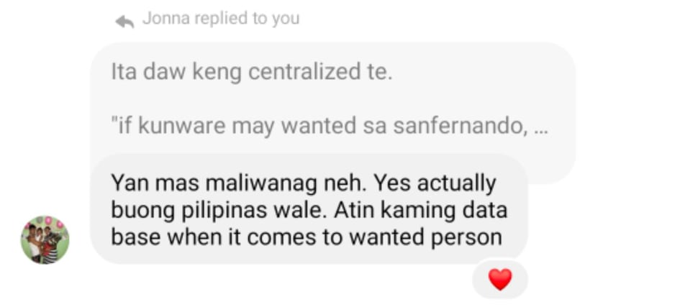

A: Eku mu sure, ita mu kasi kitang an ning panel te. Nung centralized la daw ba reng police stations.

Siya: Makananung centralized, when it comes to?

A: Ali kumu sure te.

Siya: Eke asagut, centralized when it comes to what matter.

A: Sige te lampasan tane pa.

A: Nanung medium ing gagamitan para makapag report kekayu te? Atin bang email, atin bang text, atin bang. Nanu pang aliwang gamit medium.

Siya: ing mu talagang gagamitan, actually ing email malabu yapa e, through call and text talaga. Pero pangaras kasi keng text ekami masyadu mag stick keng text. Ken kami mu mostly keng calls, kasi keng call mas akutnan me masalese ing tawu, makakwa kaming information. Mas mabilis kasi ing communication if through call.

Siya: Mamye kaming flyers karetang hotline numbers na pwedi dang awsan. Pwedi rin mawus ka 911 then 911 will coordinate.

A: Meglage kami din hotlines ketang app te, meglage kami Karin.

Siya: Pero may question ako, kung nagbigay ng cellphone number, kanino cellphone number yon?

Siya: Sinong cellphone number yung nilagay niyo?

(Sabi ko dito, sa mga municipality kase uncertain ako sa isasagot ko kung san niyo galing yung hotlines.)

Siya: I think it should be verified.

A: Ahh awa sige te.

A: Init e, pag nireport yaba keng Womens Desk, Women Desk yamu ba ing maghandle or buong PNP or abe la reng PNP?

Siya: Womens Desk?

A: Awa te, kunwari itang sinabi mu nandin. WCPD, Karin de nireport te. Maghandle mu ba Karin ing WCPD?

Siya: Halimbawa nireport me keng WCPD, ing San Fernando WCPD ing mag response.

A: Alang aliwang department ing makyalam ne te?

Siya: No, It depends.

(DITO SOBRANG HIRAP KO NA SIYA MARINIG KAYA BINABASA KO NALANG LIPS NIYA)

Siya: If me report ya kasi keng WCPD dipendi ya padin keng case. Pero ing WCPD ing maglakad, makipag coordinate ya padin.

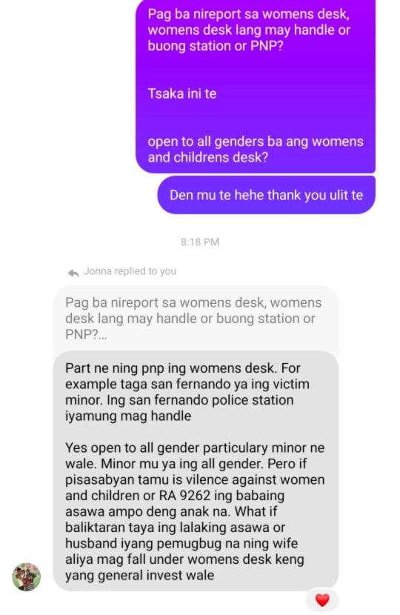

(YUNG LAST KONG TANONG HINDI KO NA SIYA MAINTINDIHAN, TANONG KO NALANG ULIT SA CHAT)

Unang step daw papa fill upan tsaka pirma sa Complaint form.

Tapos gagawa sila ng request. Halimbawa rape case,gagawa sila ng medical request. After ng request syempre imemedical na. After non interview na, lahat ng need, ano name niya, age, kung minor man pati nameng parents need at kung minor man dapat may kasamang guardian. Edad tsaka kung taga saan.

Tapos itatanong din name ng suspect, san nakatira, kahit hindi na alam ang age basta ang importante daw ang name or kung kilala ng victim.

Pag hindi kilala, makikipag coordinate sila sa VAW Desk ng barangay.

And most importantly, itatanong na yung incident, lahat ng possible na itanong itatanong na nila.

Tapos after daw non, tutulungan yung victim sa prosecutors office, tapos tatanggapin ng prosecutors office yung reklamo tapos mag hihintay nalang mag release ng subpoena kung kailan ang hearing. Tapos tuloy tuloy na hanggang sa Court. This time mag te-take over na yung Court.

| 1. Fill up and Sign the Complaint Form | |
| --- | --- |
| 2a. Regular Filing ( if the incident happened beyond 36 hrs) | 2b. Inquest Filing ( if the incident happened inside the 36hrs) |
| 3. Police will file for a Request  (medical request, psychological request etc.) | |
| 4.Interview with the Complainant   * Victim Side  1. Name 2. Address 3. Age 4. Birthday 5. Civil Status 6. Parent/Guardian (if Minor) 7. Nature of Complaint 8. Date and time of Abuse/ Incident  * Suspect  1. Name 2. Age 3. Address 4. Incase na hindi kilala, makikipag coordinate ang Station sa Barangay VAW Desk | |
| 5. Investigation about the Incident   * the police will ask specific questions about the incident | |
| 6. Police will assist the victim to the Prosecutor’s Office, and the court will take over the case. | |